Assignment 2(3)
Topics: Confidence Interval

- For each of the following statements, indicate whether it is True/False. If false, explain why.

- The sample size of the survey should at least be a fixed percentage of the population size in order to produce representative results.
Ans: False. Even a sample size of 30 often increases the confidence interval of your population data set enough to warrant assertions against your findings.

- The sampling frame is a list of every item that appears in a survey sample, including those that did not respond to questions.
Ans: False. The sampling frame refers to a list of an item which responds to the question and not the ones which do not respond to the questions.

- Larger surveys convey a more accurate impression of the population than smaller surveys.
Ans: True. A sufficiently large sample size can predict the characteristics of a population more accurately.

- PC Magazine asked all of its readers to participate in a survey of their satisfaction with different brands of electronics. In the 2004 survey, which was included in an issue of the magazine that year, more than 9000 readers rated the products on a scale from 1 to 10. The magazine reported that the average rating assigned by 225 readers to a Kodak compact digital camera was 7.5. For this product, identify the following:

- The population: All the readers of PC Magazine

- The parameter of interest: Parameter of interest is a statistical value that gives you more information about the research sample or population being studied. Here it is sizes of population and sample, average rating to kodak compact digital camera (here, 7.5)

- The sampling frame: All those who responded (rated) the products; Here 9000

- The sample size: 225 readers

- The sampling design: Voluntary response sample where the researcher puts out a request for members of a population to join the sample, and people decide whether or not to be in the sample

- Any potential sources of bias or other problems with the survey or sample: It excludes data from that section of users who use these products but do not read PC magazine. Moreover, all those who read magazine would not necessarily respond to survey. Among those who respond to survey, proportion of those users who are highly satisfied or highly unpleased is quite high.

- For each of the following statements, indicate whether it is True/False. If false, explain why.

- If the 95% confidence interval for the average purchase of customers at a department store is $50 to $110, then $100 is a plausible value for the population mean at this level of confidence.
Ans: True

- If the 95% confidence interval for the number of moviegoers who purchase concessions is 30% to 45%, this means that fewer than half of all moviegoers purchase concessions.
Ans: False. Above Statement is 95% confident (assured) that 30 to 45 percent i.e. less than half of moviegoers purchase concessions, but still there is 5% chance that above statement is false.

- The 95% Confidence-Interval for μ only applies if the sample data are nearly normally distributed.
Ans: False. If you have a data which is not normally distributed then increasing sample size beyond 30 will help to make that data an approximate normal distribution regardless of distribution of the original data.

- What are the chances that ?

- ¼ B. ½ C. ¾ D. 1

Ans: The expected value of the mean of a sample (x-bar) is equal to the mean of the population (µ).) The law of large numbers says that x-bar will be close to µ for large n (n is the size of the sample).
Hence, option A

- In January 2005, a company that monitors Internet traffic (WebSideStory) reported that its sampling revealed that the Mozilla Firefox browser launched in 2004 had grabbed a 4.6% share of the market.

- If the sample were based on 2,000 users, could Microsoft conclude that Mozilla has a less than 5% share of the market?
Ans: NO
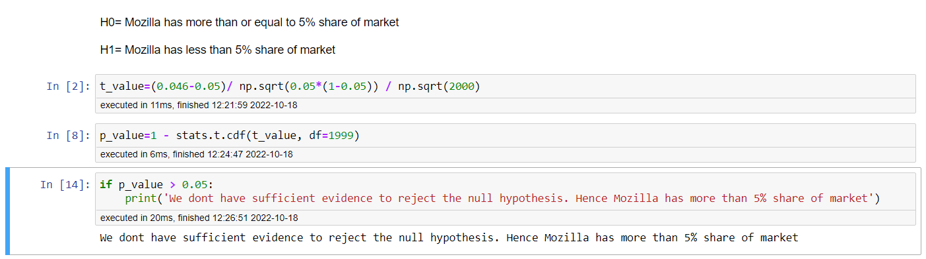

- WebSideStory claims that its sample includes all the daily Internet users. If that’s the case, then can Microsoft conclude that Mozilla has a less than 5% share of the market?
Ans: WebSideStory claims that their sample contains all the daily Internet users. Thus,4.6 percent share of market shows the entire population. So, Microsoft can conclude that the Mozilla has a less than 5% share of the market?

- A book publisher monitors the size of shipments of its textbooks to university bookstores. For a sample of texts used at various schools, the 95% confidence interval for the size of the shipment was 250 ± 45 books. Which, if any, of the following interpretations of this interval are correct?

- All shipments are between 205 and 295 books.
Ans: Incorrect. According to statement above, only 95% of the times size of shipment is between 205 and 295. But there is still 5% of the times that size of shipment goes beyond this range. So, all shipments are not between 205 and 295.

- 95% of shipments are between 205 and 295 books.
Ans: Correct

- The procedure that produced this interval generates ranges that hold the population mean for 95% of samples.
Ans: Correct

- If we get another sample, then we can be 95% sure that the mean of this second sample is between 205 and 295.
Ans: Yes, correct.

- We can be 95% confident that the range 160 to 340 holds the population mean.
Ans: Incorrect. For confidence interval of mean +/- 1 sigma we have confidence of 95%.
If we increase the range of interval to mean +/- 2 sigma then confidence will also increase.

- Which is shorter: a 95% z-interval or a 95% t-interval for μ if we know that σ =s?
- The z-interval is shorter
- The t-interval is shorter
- Both are equal
- We cannot say
Ans: A. 95% confident Z-interval is shorter (1.960) than t-interval (1.962)

Questions 8 and 9 are based on the following: To prepare a report on the economy, analysts need to estimate the percentage of businesses that plan to hire additional employees in the next 60 days.

- How many randomly selected employers (minimum number) must we contact in order to guarantee a margin of error of no more than 4% (at 95% confidence)?
- 600
- 400
- 550
- 1000
Ans: A
The margin of error is defined as the range of values below and above the sample statistic in a confidence interval. Margin of error of 4% means the results to be within 4 percent of the stated result 95 percent of the time.

Margin of Error = Z * sqrt (p_cap *(1-p_cap)/ n)

0.04 = 1.96 * sqrt (0.5*0.5/n) __________Assuming p = 0.5
n = 600.730

- Suppose we want the above margin of error to be based on a 98% confidence level. What sample size (minimum) must we now use?

- 1000
- 757
- 848
- 543
Ans: C
Margin of Error = Z * sqrt (p_cap *(1-p_cap)/ n)
0.04 = 2.326 * sqrt (0.5*0.5/n)
n = 845.35

Thank You

